INGLES 6to BASICO
Prof. ANDREA WALKER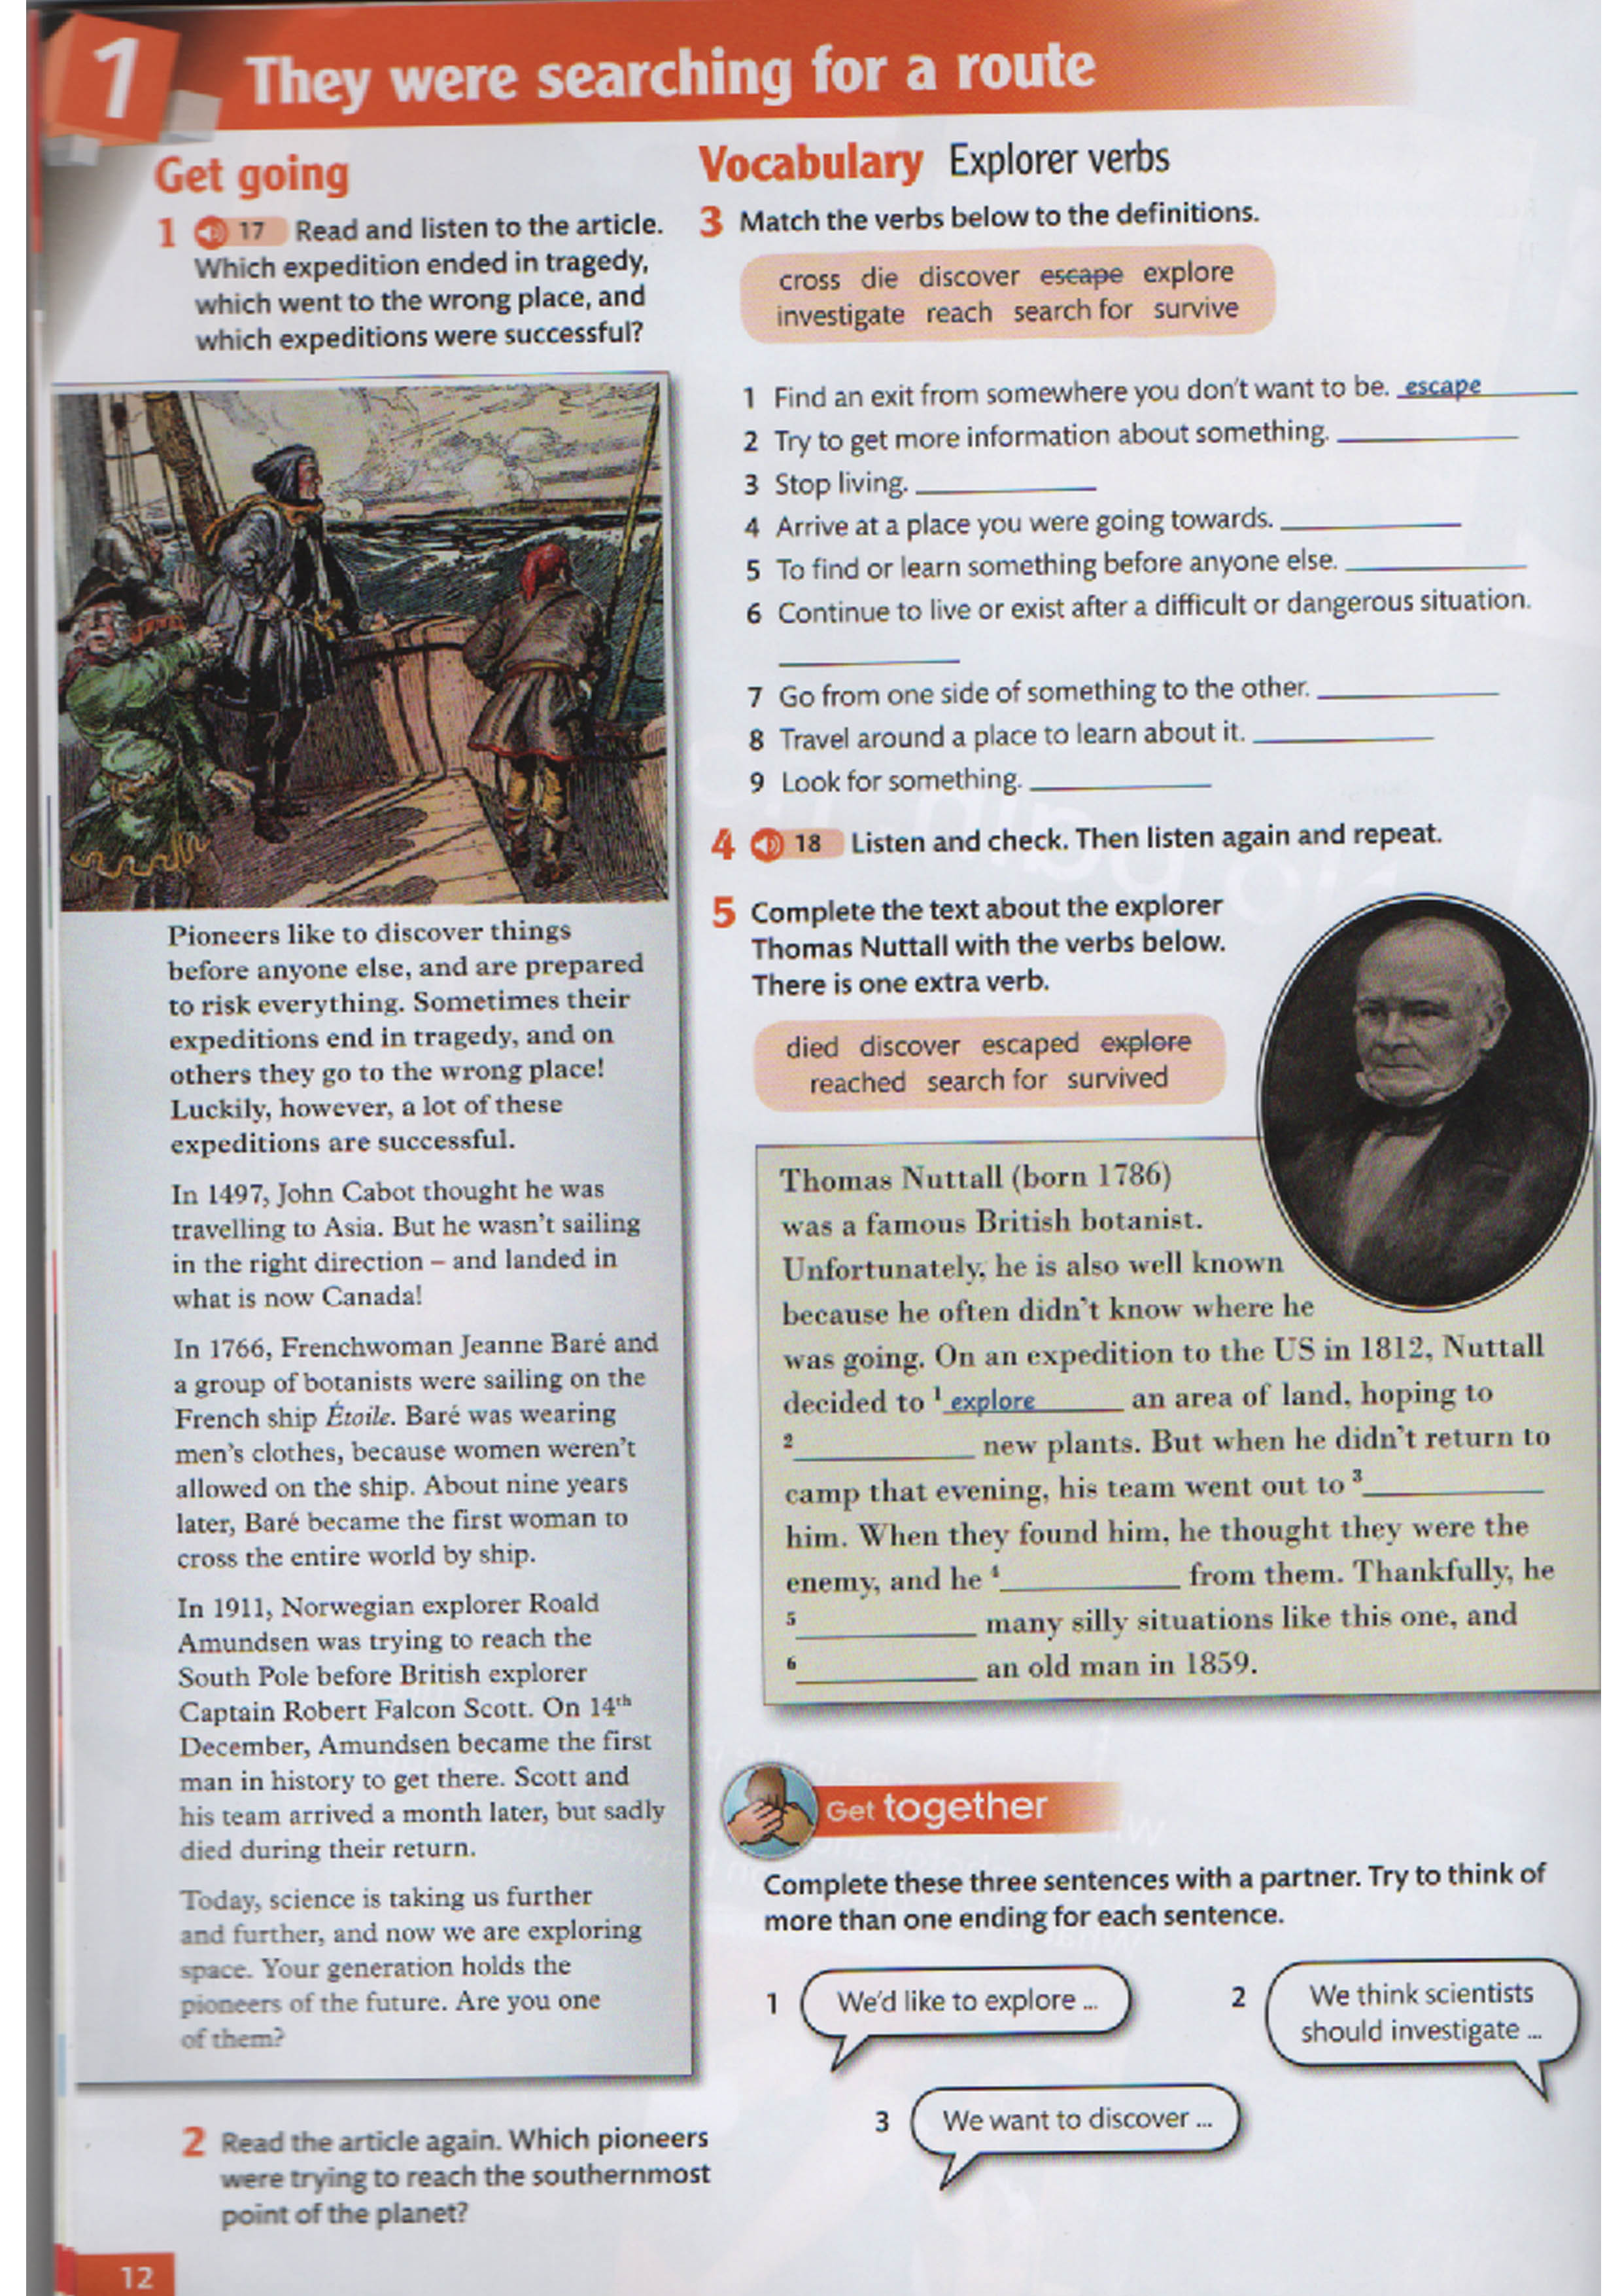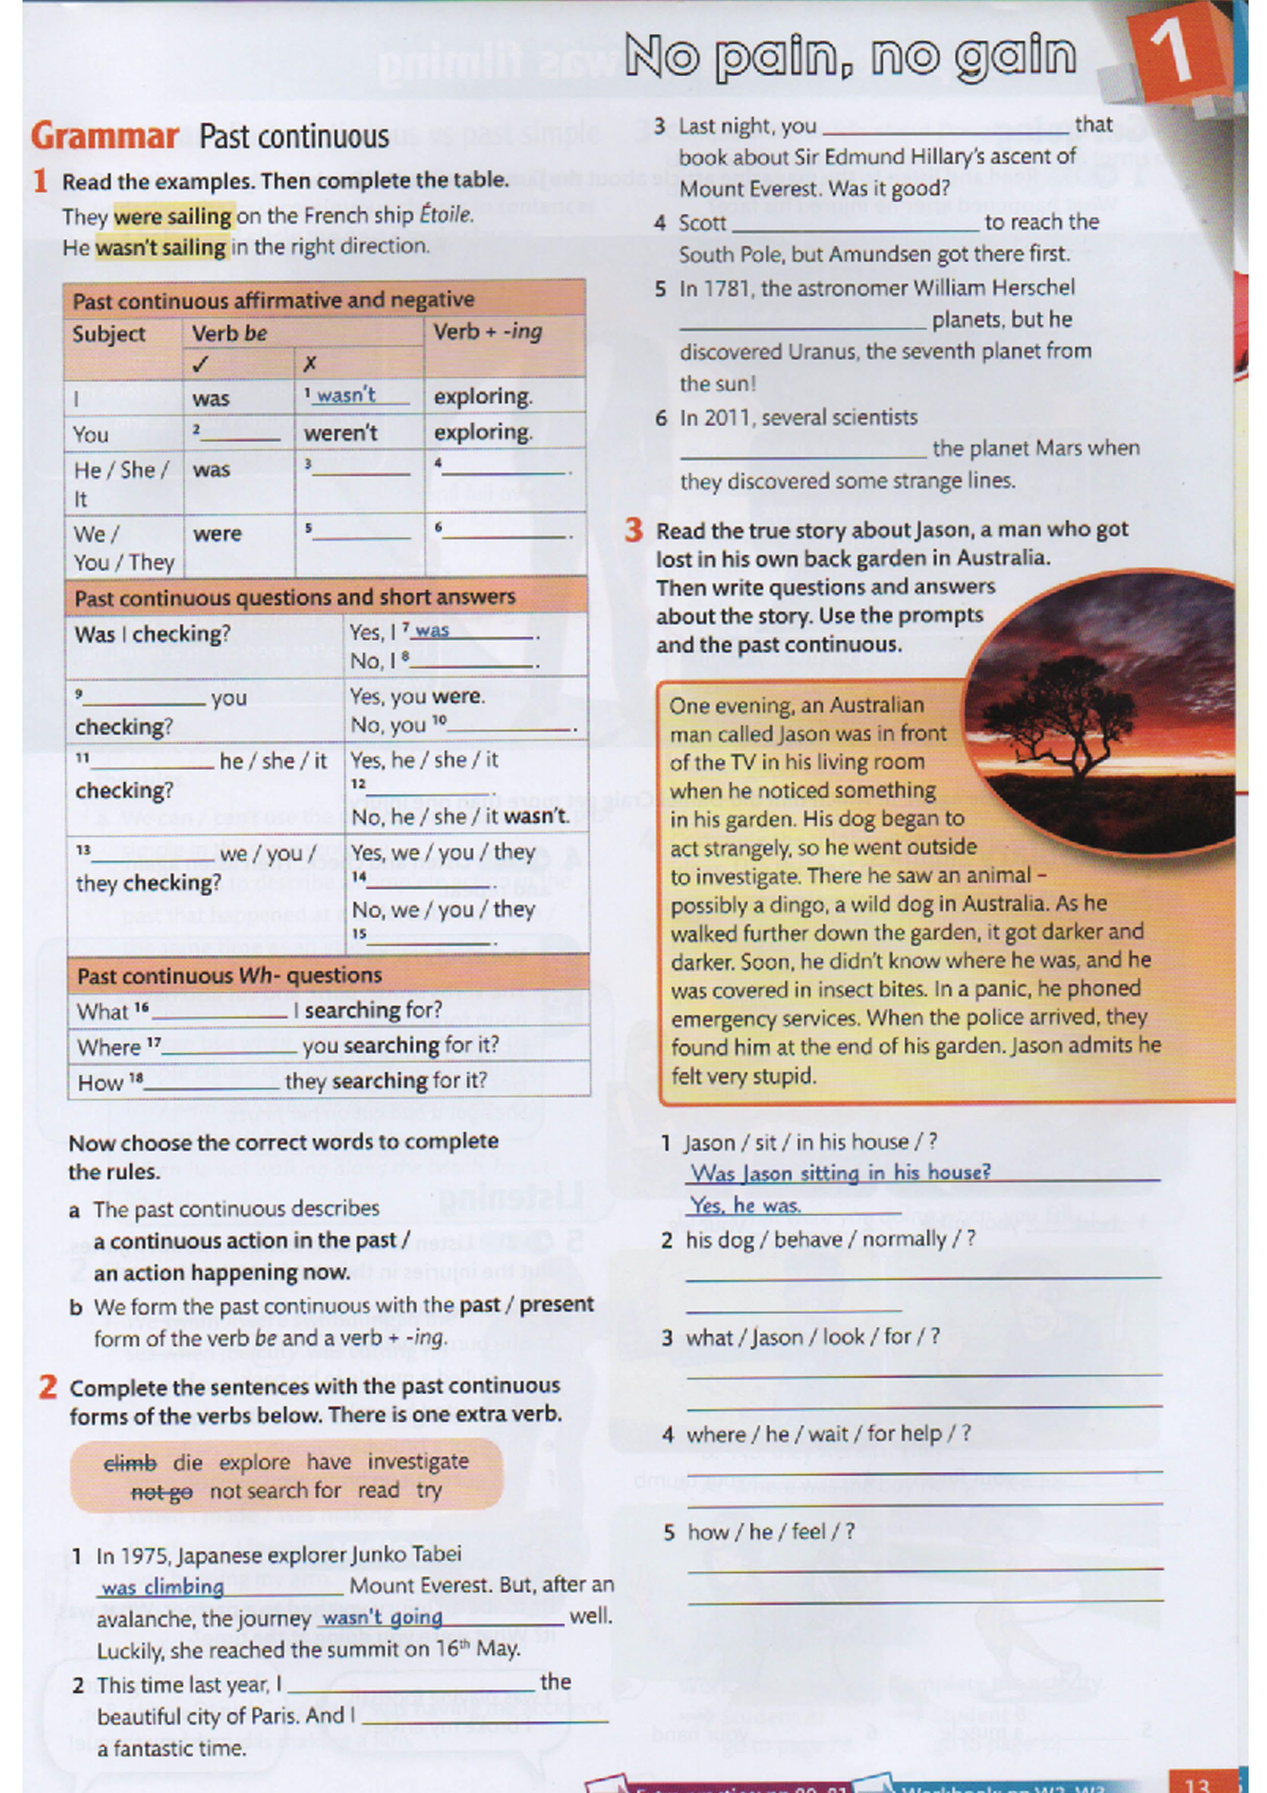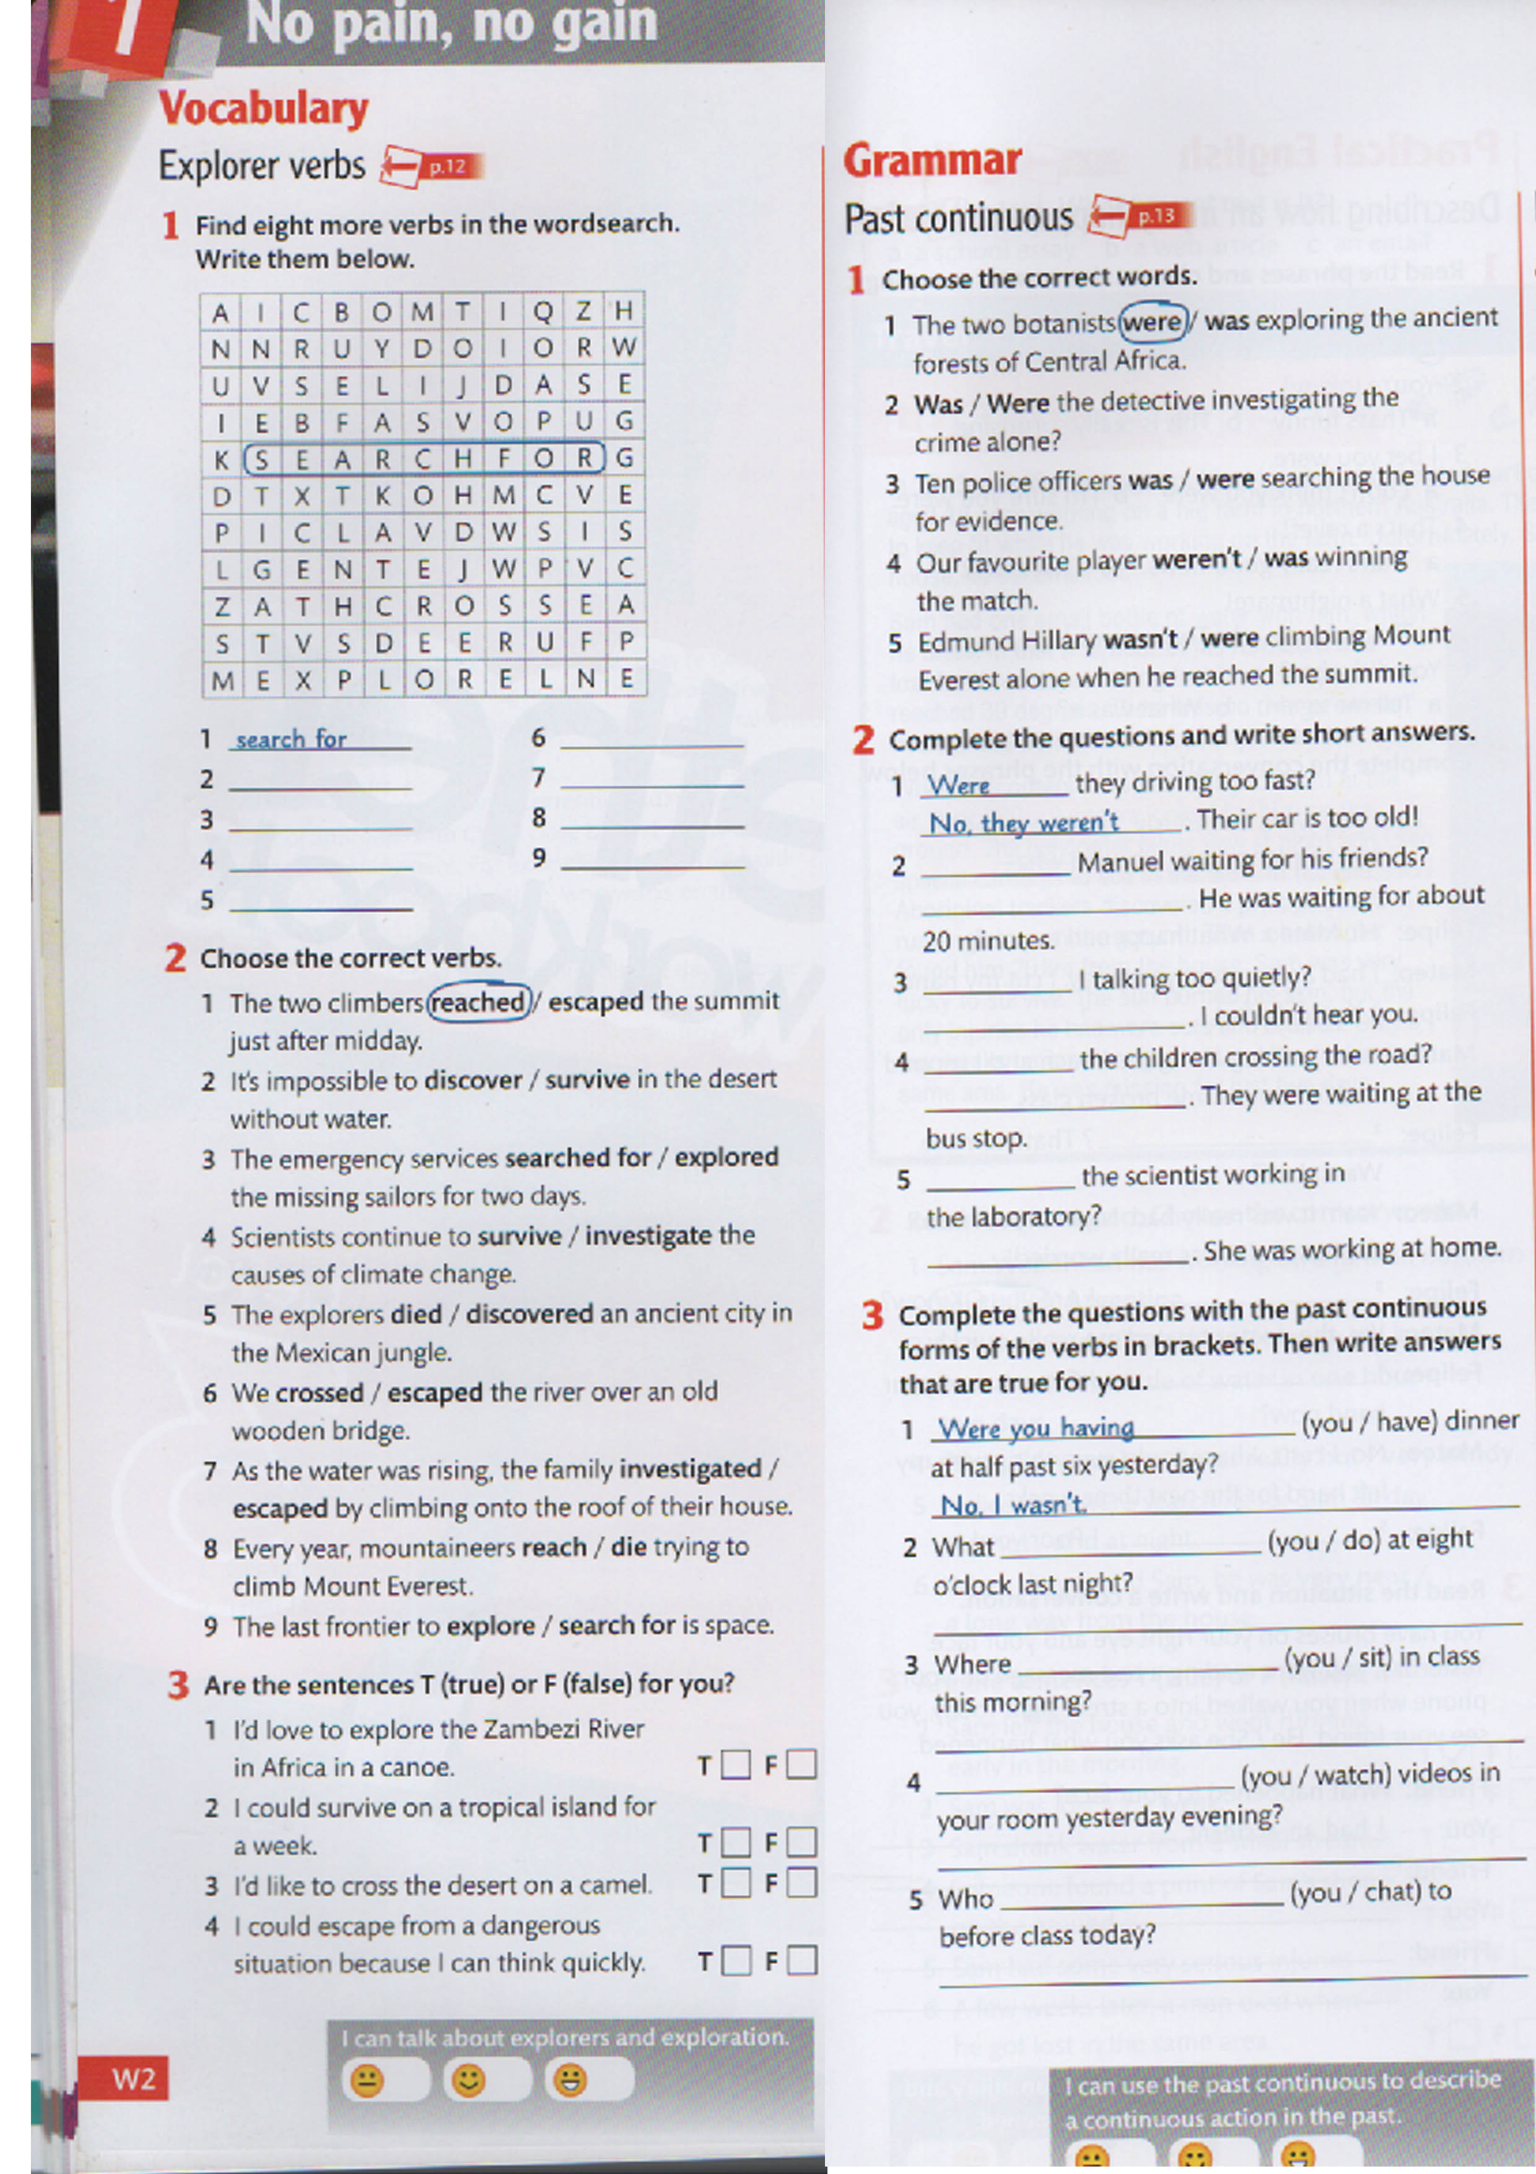

Links Audio
https://drive.google.com/open?id=1qED1_mnnxcuWTM9zEGvI11D4PYOtCdYH

